**Summary of Analysis of Psychological Wellness of Students**

**1st Year Students-ECE Branch of GRIET**

A Psychological wellness test was conducted to 1st year ECE Students and conclusions were drawn. The following are the major findings.

1. Self-Awareness: 24.52% of students in ECE A, 10.16% of students in ECE B, 18.18% of students in ECE C 24.52% of students in ECE D and 24.52% of students in ECE E are not having proper awareness of their own feelings, emotions, weaknesses and strengths.

2. Managing Emotions: 56.36% of students in ECE A, 38.98% of students in ECE B, 45.54% of students in ECE C ,56.36% of students in ECE D and 56.36% of students in ECE E are not having the ability to manage their Emotions and feelings.

3. Motivating oneself: 56.36% of students in ECE A, 22.03% of students in ECE B, 40% of students in ECE C ,56.36% of students in ECE D and 56.36% of students in ECE E are having lower levels of motivation and not having required Zeal and Enthusiasm.

4. Empathy: 25.45% of students in ECE A, 23.72% of students in ECE B, 14% of students in ECE C ,25.45% of students in ECE D and 25.45% of students in ECE E have low level of empathy towards others.

5. Social Skills: 29.09% of students in ECE A, 16.94% of students in ECE B, 21.81% of students in ECE C ,29.09% of students in ECE D and 29.09% of students in ECE E have lower level of social skills.

### **Overall Representation of ECE Department:**

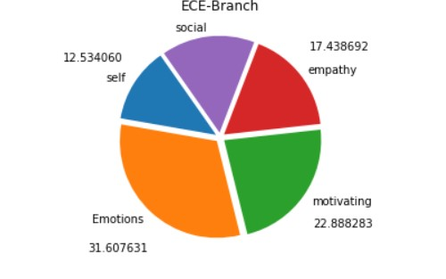

Through the diagram represents about 64% of the students affected by one or the other psychological issue. The most concerned issues among them are 1) Managing Emotions and 2) Motivating one self. Those can be learnt by Practice under the guidance of the Psychological Counsellor. The weaknesses of the students will be addressed by the counsellor from time to time.

### **Detailed Analysis -ECE Branch**

### **Section** Total Students Participated: 270**2**

### **Self-Awareness:**

**Analysis of the given graph:** The above graph depicts the results of the psychological test on the self-awareness questions. The bars in green color indicates that the student’s score is above 35 and the bars in the red color indicates that the student’s score is less than 35.Above 35 score students have better Self-awareness. Less than 35 Score indicates that those students require personal counseling to enhance their Self-awareness skills.

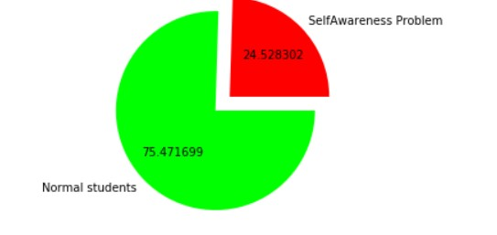

**Analysis:** From the information shown in the above pie chart, the large green color area indicates that 75.47% of the students have self-awareness and these students don’t require counseling whereas the rest 24.52% of the students don’t seem to have self-awareness.Hence, they need to be counseled.

### **Social weakness among students:**

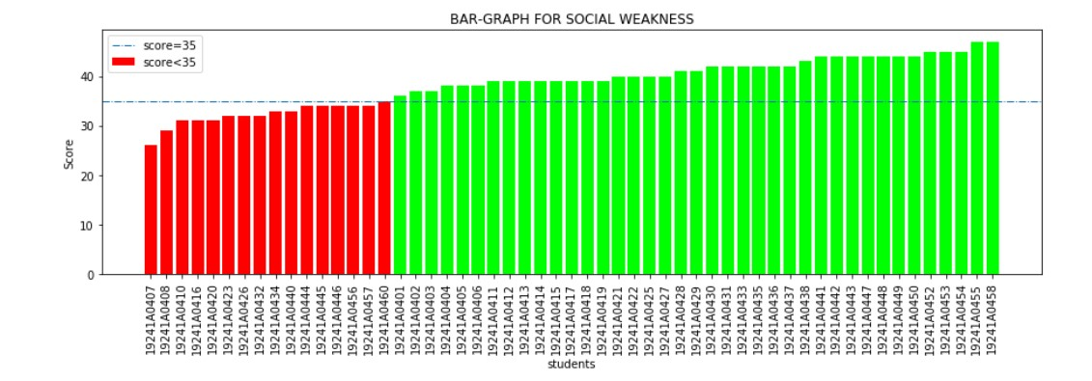

### **Analysis of the given graph:** The above graph depicts the results of the behavioral test-Social weakness questions attempted by the 1st year students. The bars in green color indicate that the student’s score is above 35 and the bars in red color indicate that the student’s score is less than 35.

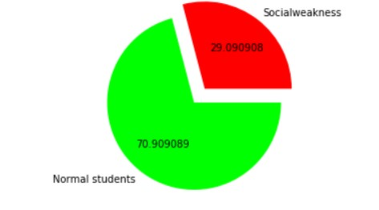

### **Analysis:** From the information shown in the above pie chart, the large green color area indicates that 70.90% of the students are good at social awareness and these students don’t require counseling, whereas the rest 29.09% of the students don’t seem to manage their emotions well. Hence, they need to be counseled.

### **Empathy among students**

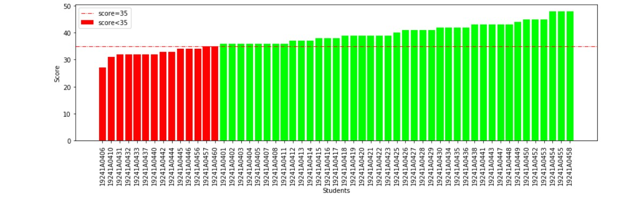

### **Analysis of the given graph:** The above graph depicts the results of the behavioral test-empathy questions attempted by the 1st year students. The bars in green color indicate that the student’s score is above 35 and the bars in red color indicate that the student’s score is less than 35.

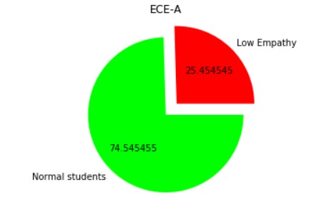

### **Analysis:** From the information shown in the above pie chart, the large green color area indicates that 74.54% of the students are good at empathy and these students don’t require counseling, whereas the rest 25.45% of the students don’t seem to manage their emotions well. Hence, they need to be counseled.

### **Motivating Oneself**

### **10**

### **Analysis of the given graph:** The above graph depicts the results of the behavioral test-Motivating Oneself questions attempted by the 1st year students. The bars in green color indicate that the student’s score is above 35 and the bars in the red color indicate that the student’s score is less than 35.

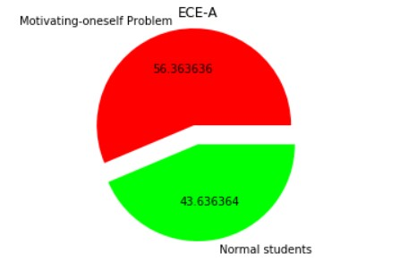

### **Analysis:** From the information shown in the above pie chart, the large green color area indicates that 56.36% of the students do not have social weakness and these students don’t require counseling, whereas the rest 43.63% of the students have social weakness.Hence, they need to be counseled.

### **Managing Emotions:**

### 8

### **Analysis of the given graph:** The above graph depicts the results of the behavioral test-Managing Emotions questions attempted by the 1styear students. The bars in green color indicate that the student’s score is above 35 and the bars in the red color indicate that the student’s score is less than 35.

### 7

### **Analysis** : From the information shown in the above pie chart, the large green color area indicates that 56.36% of the students are good at managing their emotions and these students don’t require counseling, whereas the rest 43.63% of the students don’t seem to manage their emotions well.Hence, they need to be counseled

### **ECE-B**

### Studentsparticipated:59

### **Self-awareness**

### sa2

### A **nalysis of the given graph**: The above graph depicts IT-B. It shows the resultsof the behavioral test-self-awareness questions attempted by the 1st year students. The bars in green color indicate that the student’s score is above 35 and the bars in the red color indicate that the student’s score is less than 35.

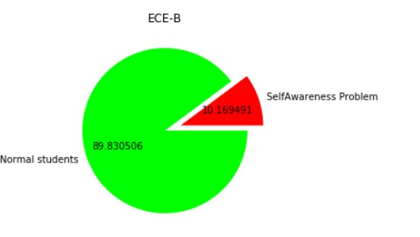

Analysis: From the information shown in the above pie chart, the large green color area indicates that 89.83% of the students have self-awareness and these students don’t require counseling whereas the rest 10.16% of the students don’t seem to have self-awareness.Hence, they need to be counseled.

### **Social Weakness**

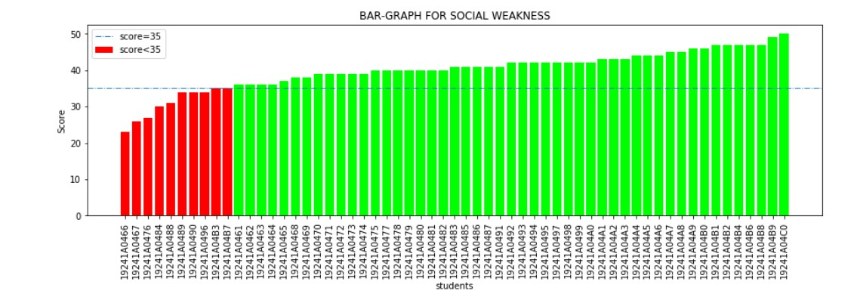

### A**Analysis of the given graph**: The above graph depicts the results of the behavioral test-Social Weakness questions attempted by the 1st year students. The bars in green color indicate that the student’s score is above 35 and the bars in the red color indicate that the student’s score is less than 35.

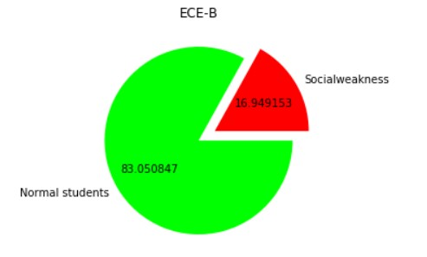

Analysis: From the information shown in the above pie chart, the large green color area indicates that 83.05% of the students are good at social awareness and these students don’t require counseling, whereas the rest 16.94% of the students don’t seem to have social weakness well.Hence, they need to be counseled.

### **Motivating One self**

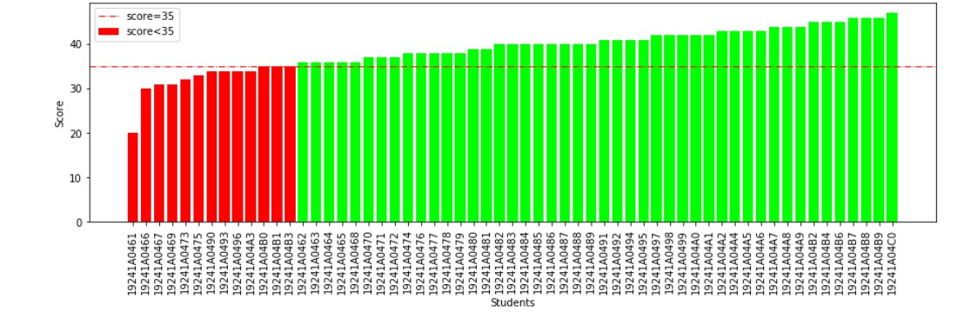

### Analysis of the given graph: The above graph depicts the results of the behavioral test-Motivating oneself questions attempted by the 1st year students. The bars in green color indicate that the student’s score is above 35 and the bars in the red color indicate that the student’s score is less than 35.

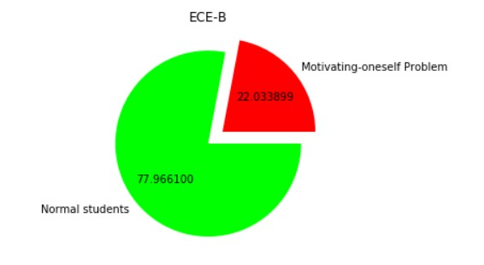

### Analysis: From the information shown in the above pie chart, the large green color area indicates that 77.96% of the students are good at motivating themselves and these students don’t require counseling,whereas the rest 22.03% of the students don’t seem good at motivating themselves.Hence, they need to be counseled.

**Empathy**

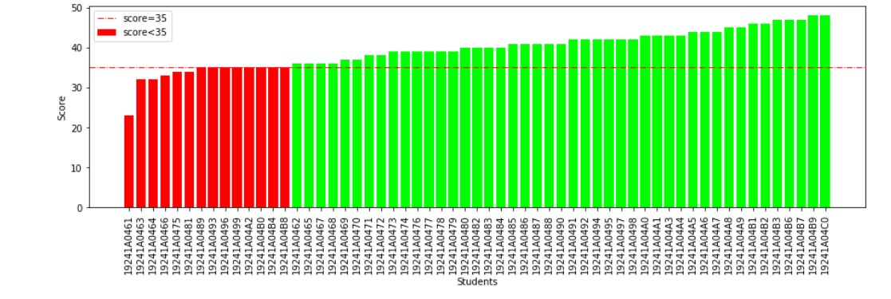

### AAnalysis of the given graph: The above graph depicts the results of the behavioral test-Empathy questions attempted by the 1styear students. The bars in green color indicate that the student’s score is above 35 and the bars in the red color indicate that the student’s score is less than 35.

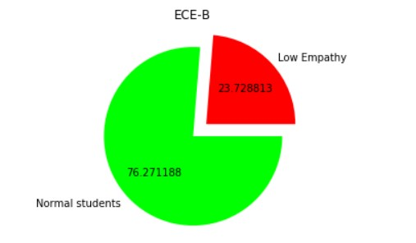

### AAnalysis: From the information shown in the above pie chart, the large green color area indicates that 76.27% of the students have good empathy and these students don’t require counseling, whereas the rest 23.72% of the students don’t seem to have empathy. Hence, they need to be counseled.

**Managing Emotions**

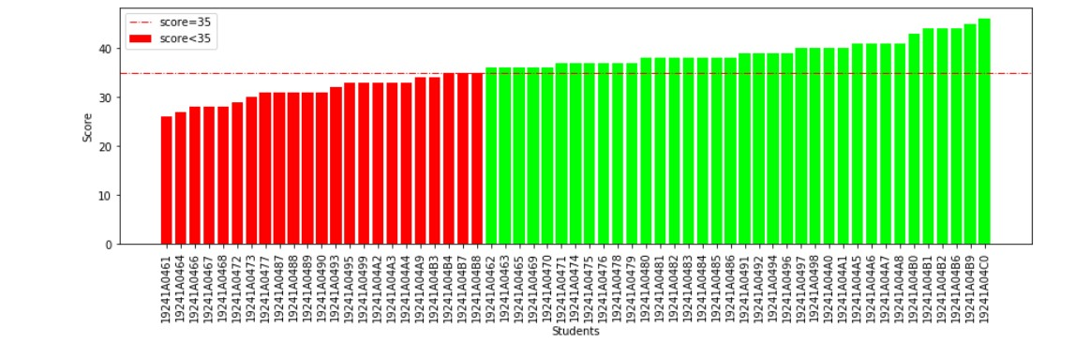

Analysis of the given graph: The above graph depicts the results of the behavioral test-Managing Emotions questions attempted by the 1styear students. The bars in green color tell that the student’s score is above 35 and the bars in the red color tell that the student’s score is less than 35.

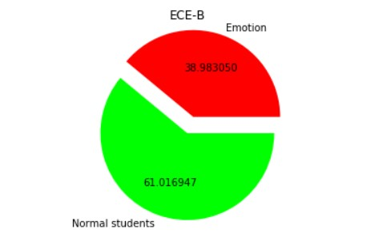

Analysis:From the information shown in the above pie chart, the large green color area tells that 61.01% of the students can manage emotions and these students don’t require counseling ,whereas the rest 38.98% of the students are not having Proper emotions management. Hence, they need to be counseled.

### **ECE -C**

### Students participated:55

### **Self-awareness**

### sa2

### A **Analysis of the given graph**: The above graph depicts ECE-C. It shows the results of the behavioral test-self-awareness questions attempted by the 1styear students. The bars in green color indicate that the student’s score is above 35 and the bars in the red color indicate that the student’s score is less than 35.

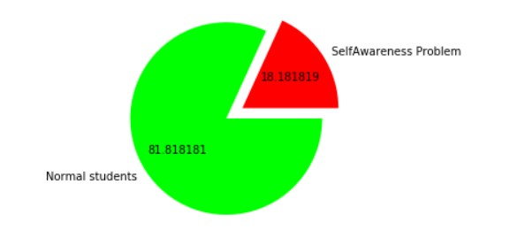

Analysis: From the information shown in the above pie chart, the large green color area indicates that 81.81% of the students have self-awareness and these students don’t require counseling whereas the rest 18.18% of the students don’t seem to have self-awareness. Hence, they need to be counseled.

### **Social Weakness**

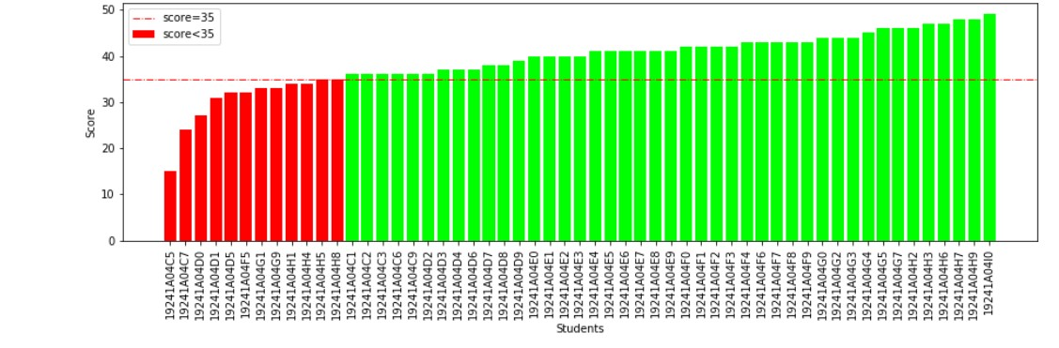

**Analysis of the given graph**: The above graph depicts the results of the behavioral test-Social Weakness questions attempted by the 1st year students. The bars in green color indicate that the student’s score is above 35 and the bars in the red color indicate that the student’s score is less than 35.

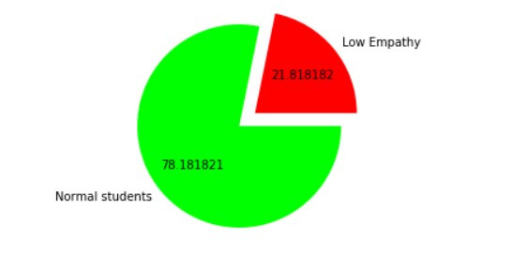

Analysis: From the information shown in the above pie chart, the large green color area indicates that 78.18% of the students are good at social awareness and these students don’t require counseling, whereas the rest 21.81% of the students don’t seem to have social weakness well. Hence, they need to be counseled.

### **Motivating One self**

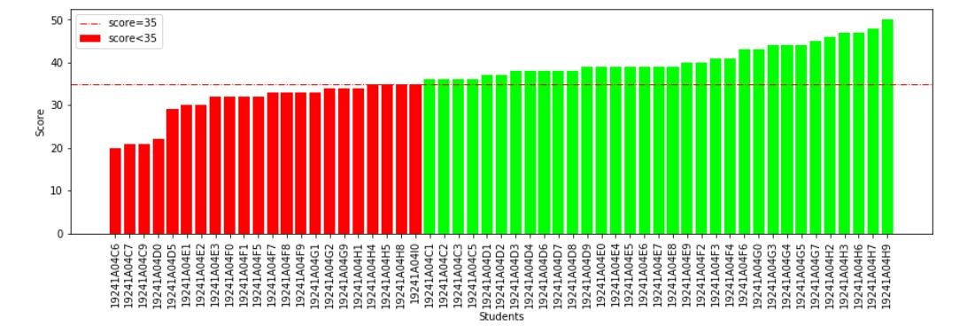

### Analysis of the given graph: The above graph depicts the results of the behavioral test-Motivating oneself questions attempted by the 1st year students. The bars in green color indicate that the student’s score is above 35 and the bars in the red color indicate that the student’s score is less than 35.

### mo1

### Analysis: From the information shown in the above pie chart, the large green color area indicates that 60% of the students are good at motivating themselves and these students don’t require counseling, whereas the rest 40% of the students don’t seem good at motivating themselves. Hence, they need to be counseled.

**Empathy**

### AAnalysis of the given graph: The above graph depicts the results of the behavioral test-Empathy questions attempted by the 1styear students. The bars in green color indicate that the student’s score is above 35 and the bars in the red color indicate that the student’s score is less than 35.

### AAnalysis: From the information shown in the above pie chart, the large green color area indicates that 77.55% of the students have good empathy and these students don’t require counseling, whereas the rest 22.44% of the students don’t seem to have empathy. Hence, they need to be counseled.

**Managing Emotions**

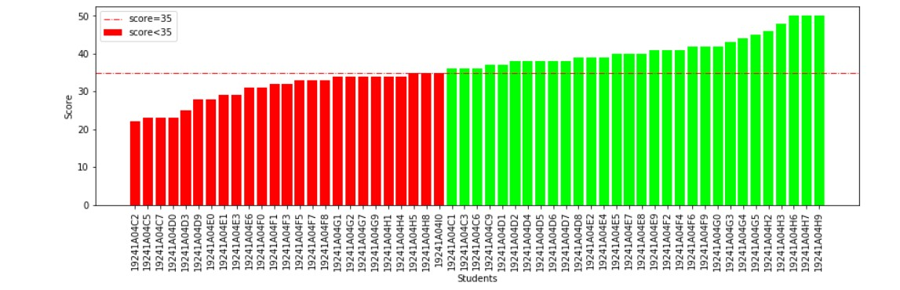

Analysis of the given graph: The above graph depicts the results of the behavioral test-Managing Emotions questions attempted by the 1styear students. The bars in green color tell that the student’s score is above 35 and the bars in the red color tell that the student’s score is less than 35.

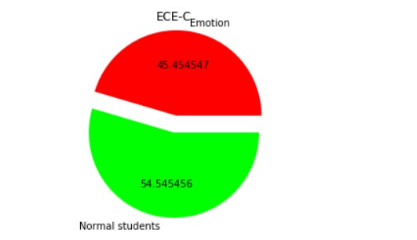

Analysis: From the information shown in the above pie chart, the large green color area tells that 54.54% of the students can manage emotions and these students don’t require counseling, whereas the rest 45.45% of the students are not having Proper emotions management. Hence, they need to be counseled.

### **ECE -D**

### Studentsparticipated:53

### **Self-awareness**

### SA2

### A **nalysis of the given graph**: The above graph depicts ECE-D. It shows the resultsof the behavioral test-self-awareness questions attempted by the 1st year students. The bars in green color indicate that the student’s score is above 35 and the bars in the red color indicate that the student’s score is less than 35.

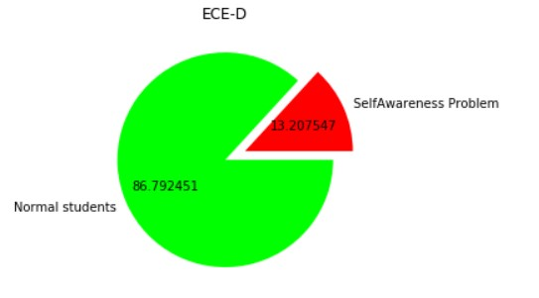

Analysis: From the information shown in the above pie chart, the large green color area indicates that 86.79% of the students have self-awareness and these students don’t require counseling whereas the rest 13.20% of the students don’t seem to have self-awareness.Hence, they need to be counseled.

### **Social Weakness**

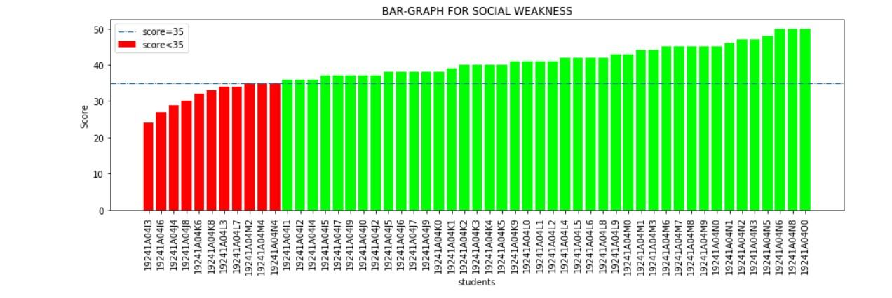

### A**Analysis of the given graph**: The above graph depicts the results of the behavioral test-Social Weakness questions attempted by the 1st year students. The bars in green color indicate that the student’s score is above 35 and the bars in the red color indicate that the student’s score is less than 35.

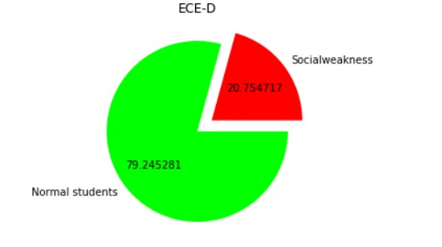

Analysis: From the information shown in the above pie chart, the large green color area indicates that 79.24% of the students are good at social awareness and these students don’t require counseling, whereas the rest 20.75% of the students don’t seem to have social weakness well.Hence, they need to be counseled.

### **Motivating One self**

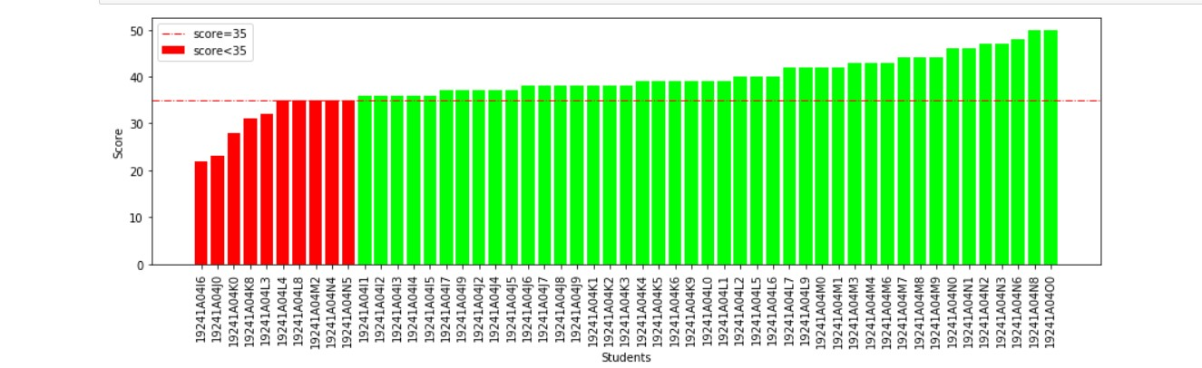

### Analysis of the given graph: The above graph depicts the results of the behavioral test-Motivating oneself questions attempted by the 1st year students. The bars in green color indicate that the student’s score is above 35 and the bars in the red color indicate that the student’s score is less than 35.

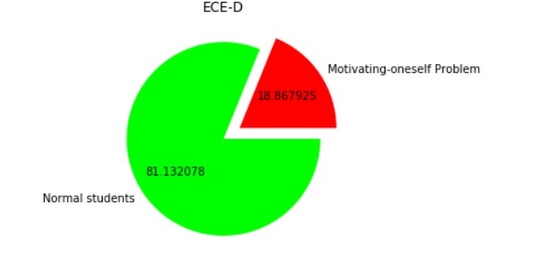

### Analysis: From the information shown in the above pie chart, the large green color area indicates that 81.13% of the students are good at motivating themselves and these students don’t require counseling,whereas the rest 18.86% of the students don’t seem good at motivating themselves.Hence, they need to be counseled.

**Empathy**

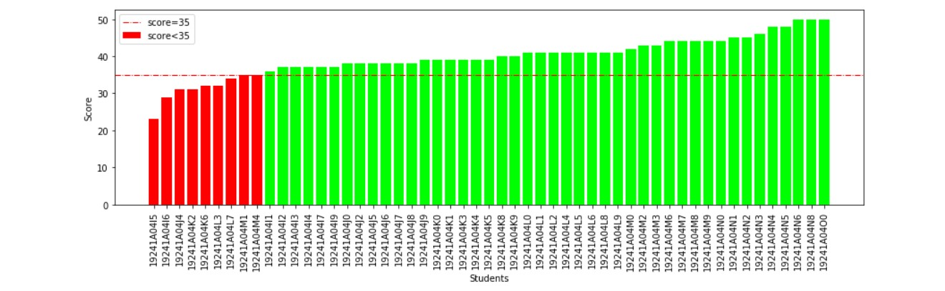

### AAnalysis of the given graph: The above graph depicts the results of the behavioral test-Empathy questions attempted by the 1styear students. The bars in green color indicate that the student’s score is above 35 and the bars in the red color indicate that the student’s score is less than 35.

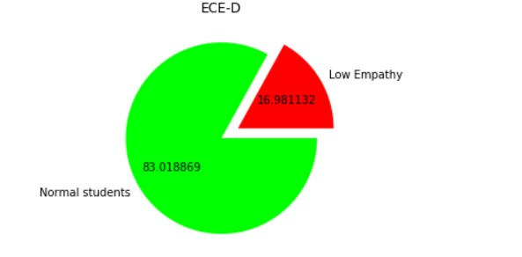

### AAnalysis: From the information shown in the above pie chart, the large green color area indicates that 83% of the students have good empathy and these students don’t require counseling, whereas the rest 16.98% of the students don’t seem to have empathy. Hence, they need to be counseled.

**Managing Emotions**

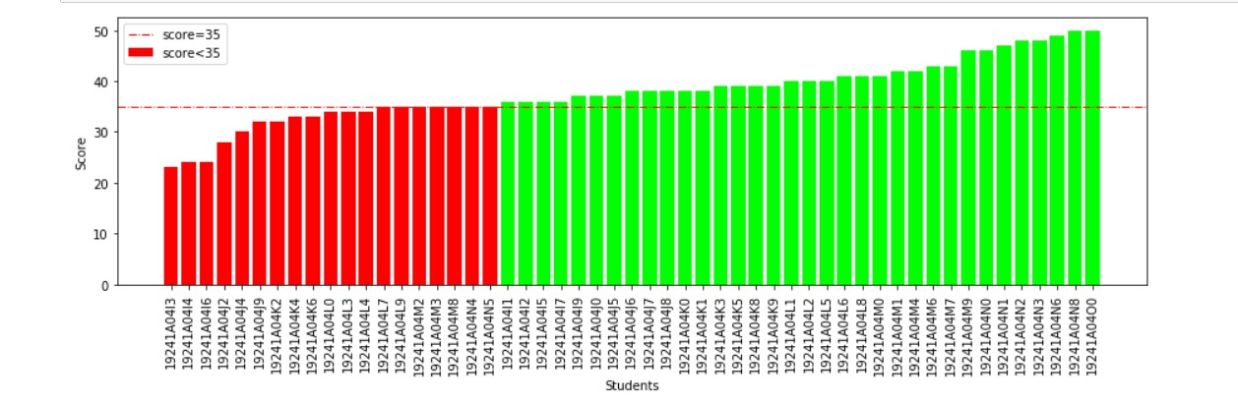

Analysis of the given graph: The above graph depicts the results of the behavioral test-Managing Emotions questions attempted by the 1styear students. The bars in green color tell that the student’s score is above 35 and the bars in the red color tell that the student’s score is less than 35.



Analysis:From the information shown in the above pie chart, the green color area tells that 81.13% of the students can manage emotions and these students don’t require counseling ,whereas the rest 18.86% of the students are not having Proper emotions management. Hence, they need to be counseled.

### **ECE-E**

### Students participated:48

### **Self-awareness**

### SA2

### A **Analysis of the given graph**: The above graph depicts ECE-E. It shows the results of the behavioral test-self-awareness questions attempted by the 1styear students. The bars in green color indicate that the student’s score is above 35 and the bars in the red color indicate that the student’s score is less than 35.

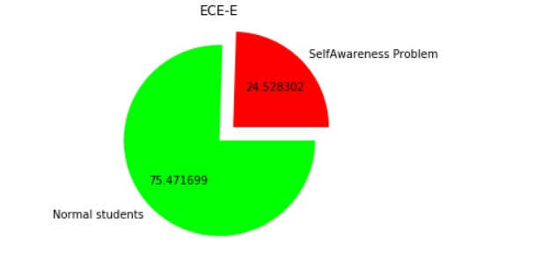

Analysis: From the information shown in the above pie chart, the large green color area indicates that 75.47% of the students have self-awareness and these students don’t require counseling whereas the rest 24.52% of the students don’t seem to have self-awareness. Hence, they need to be counseled.

### **Social Weakness**

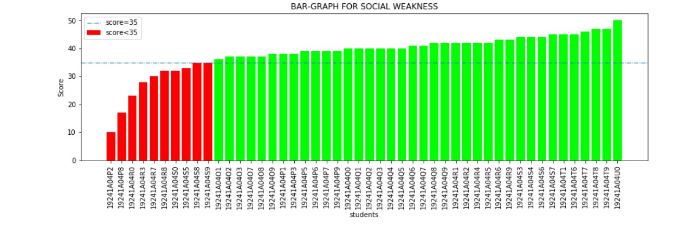

**Analysis of the given graph**: The above graph depicts the results of the behavioral test-Social Weakness questions attempted by the 1st year students. The bars in green color indicate that the student’s score is above 35 and the bars in the red color indicate that the student’s score is less than 35.



Analysis: From the information shown in the above pie chart, the large green color area indicates that 86% of the students are good at social awareness and these students don’t require counseling, whereas the rest 13% of the students don’t seem to have social weakness well. Hence, they need to be counseled.

### **Motivating One self**

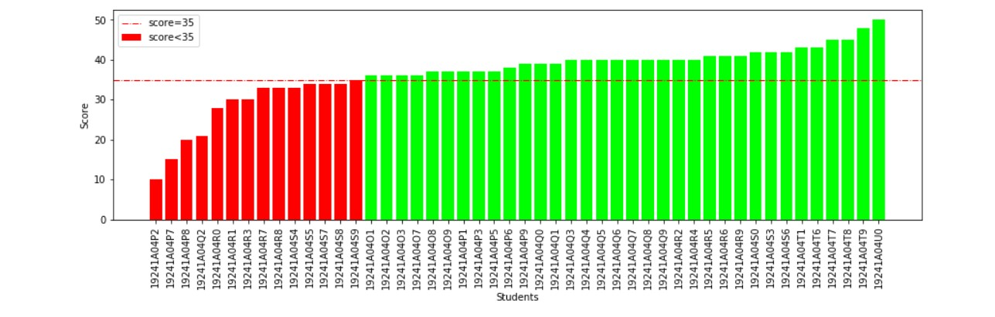

### Analysis of the given graph: The above graph depicts the results of the behavioral test-Motivating oneself questions attempted by the 1st year students. The bars in green color indicate that the student’s score is above 35 and the bars in the red color indicate that the student’s score is less than 35.

### mo

### Analysis: From the information shown in the above pie chart, the green color area indicates that 81% of the students are good at motivating themselves and these students don’t require counseling, whereas the rest 18% of the students don’t seem good at motivating themselves. Hence, they need to be counseled.

**Empathy**

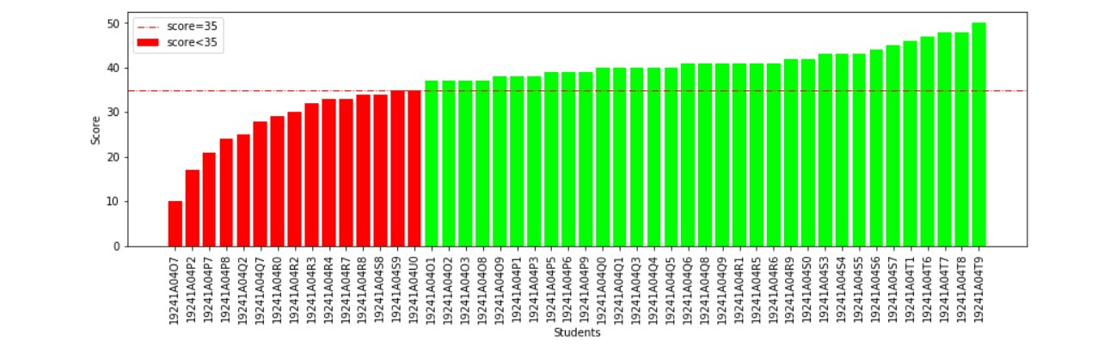

### AAnalysis of the given graph: The above graph depicts the results of the behavioral test-Empathy questions attempted by the 1styear students. The bars in green color indicate that the student’s score is above 35 and the bars in the red color indicate that the student’s score is less than 35.



### AAnalysis: From the information shown in the above pie chart, the large green color area indicates that 83% of the students have good empathy and these students don’t require counseling, whereas the rest 16% of the students don’t seem to have empathy. Hence, they need to be counseled.

**Managing Emotions**

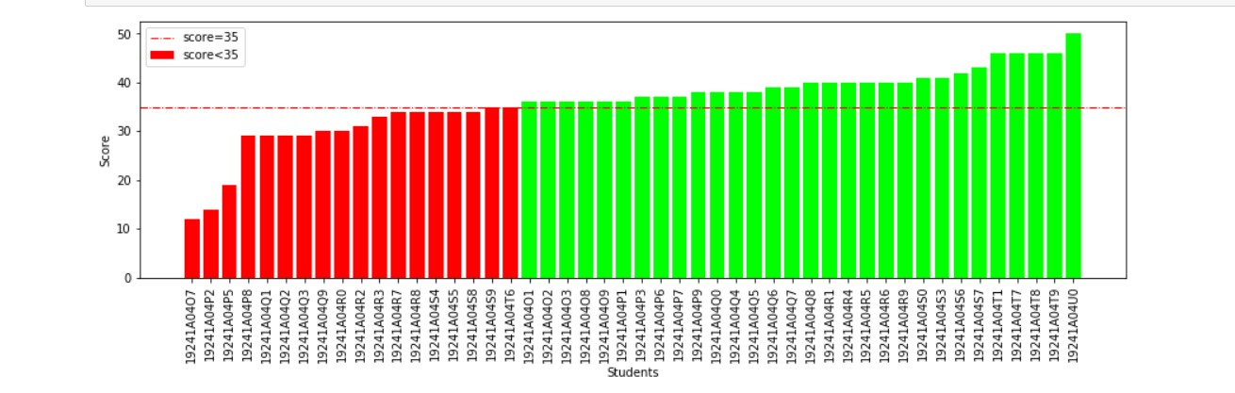

Analysis of the given graph: The above graph depicts the results of the behavioral test-Managing Emotions questions attempted by the 1styear students. The bars in green color tell that the student’s score is above 35 and the bars in the red color tell that the student’s score is less than 35.

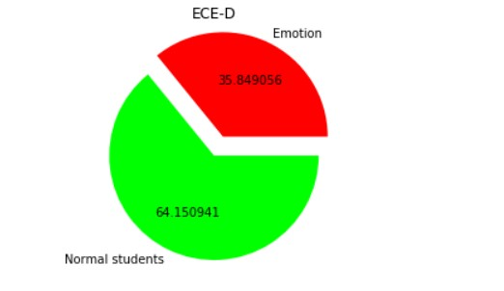

Analysis: From the information shown in the above pie chart, the green color area tells that 64% of the students can manage emotions and these students don’t require counseling, whereas the rest 35% of the students are not having Proper emotions management. Hence, they need to be counseled.

**List of students who require counseling in 1st year ECE branch:**

